\


CAMPUS CLEANER

CANDIDATE INFORMATION PACK
02
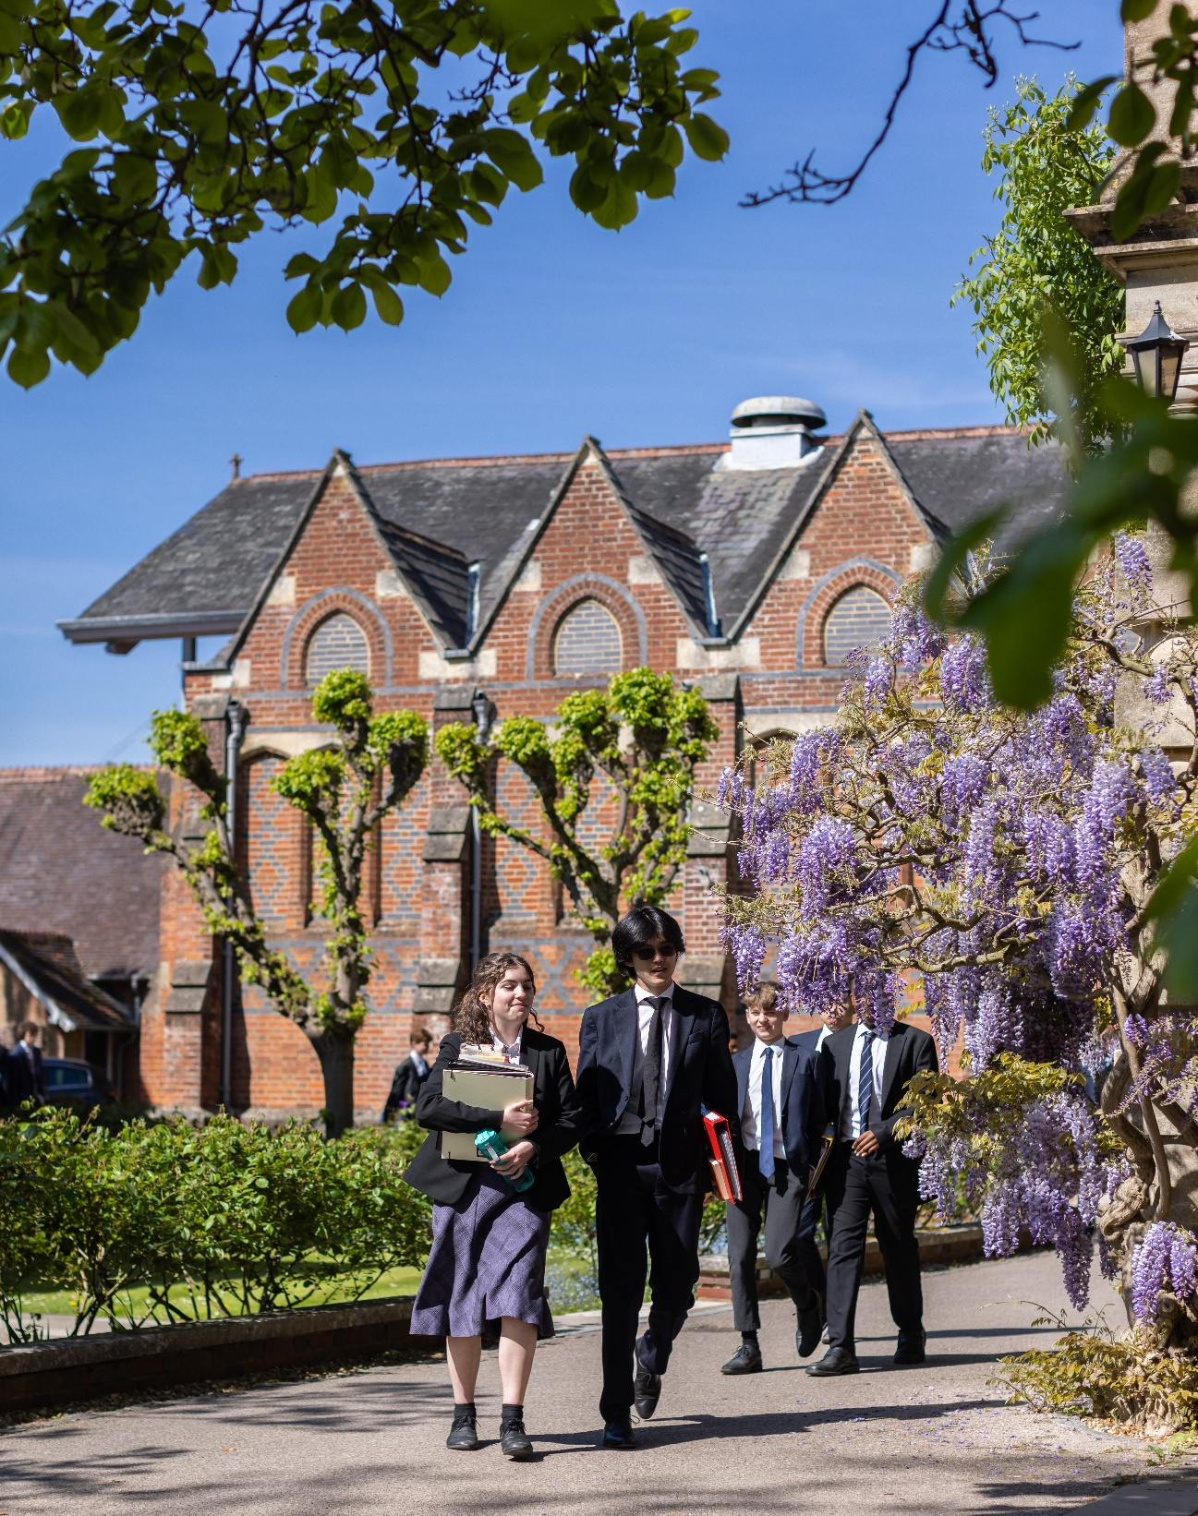
CLOSING DATE FOR APPLICATIONS 04 08 26

Early applications are encouraged, and the school reserves the right to close
the application process early should a suitable candidate be found.

PART ONE
03

ABOUT THE ROLE

Winchester College has an exciting opportunity to appoint an Evening Campus Cleaner, starting as soon as possible.

The Facilities team are responsible for the day-to-day cleanliness and event set up of all school buildings, except the boarding houses. This includes some sports facilities and all administrative offices. The areas of responsibility allocated to individual members of the Facilities team will vary from time to time and according to the team schedule. The team are required to work largely unsupervised and be flexible in order to help provide cover for absent colleagues when necessary; and be organised and have attention to detail in everything they do.

The team are also expected to follow detailed instructions and be capable of meeting the physical requirements of this role. No prior experience is required for this role with training provided; however, applicants who have experience of commercial cleaning and COSHH will be advantageous.

The Facilities team work under the day-to-day supervision of the Team Leaders and Facilities Manager. The Head of Department is the Chief Operating Officer (COO), with the Campus Cleaners line manager being the Facilities Manager. There will also be frequent contact with members of staff in the department where staff are assigned.



PART TWO

RESPONSIBILITIES OF CAMPUS CLEANER

Key Responsibilities
- To clean allocated areas. The type of cleaning will depend on the use of the building, and may include cleaning showers and WCs, sweeping, mopping, dusting, polishing, emptying bins and vacuuming. This list is not exhaustive.
- Working outside, when required to maintain cleanliness and appearance of the campus paths and associated areas.
- To periodically clean the insides of windows. Sometimes this might involve using a step ladder
- To assist in the setting up of event venues such as music rooms, exams areas, day to day school activities and functions, as well as for school open days and events.
- To assist in moving and relocating items around the campus such as furniture, event kit, tables and chairs.
- To assist other departments with moving and setting up items around the campus.
- To be able to lift reasonably heavy items such as cleaning equipment, full bin bags, and pieces of furniture etc.
- To undertake minor running repairs and immediately report any defects or safety hazards and any accidents, however small, to the Facilities Team Leaders, Facilities Manager or Heads of the Departments.
- To participate in regular routine safety checks such as fire call point/extinguishersemergency lighting, water temperature of the areas you are assigned.
- To keep up to date with cleaning methods and to undertake regular Health & Safety training, as required.
- To undertake any other work when reasonably requested by the Facilities Team Leaders, Facilities Manager or Heads of the Departments to which you have been tasked.
- Driving licence would also be an advantage, but is not essential.

Reporting Lines
The Facilities team work under the day-to-day supervision of the Team Leaders and Facilities Manager.

PART THREE

PERSON SPECIFICATION AND KEY QUALITIES
- Demonstrate a positive and flexible approach to work.
- Work both individually and as part of a team, contributing to the team spirit.
- Use their initiative.
- Demonstrate high levels of energy, enthusiasm and reliability.
- Good attention to detail.
- Prioritise tasks and manage their time well/productively; and
- A commitment to promoting and embedding an inclusive culture, with equality of opportunity for all.
  - Free staff lunches during term time.
  - Free use of some sports facilities and discounted hire charges for others
  - Tour of the College, with discounted rates available for booking venues within the school’s
grounds for hospitality events.
  - Cycle to work scheme.
  - Free access to an ongoing cycle of cultural, musical, theatrical and sporting talks and events.
  - Employee Referral Scheme, with a reward of up to £250 for staff (subject to scheme conditions).
  - Free Library membership with access to a range of online journals and magazines.



PART FOUR

BENEFITS, TERMS AND CONDITIONS AND APPLICATION

Start Date
Flexible start date for the right candidate with preference for as soon as possible

Hours of Work
We have two vacancies one for 12.5 hours per week and another for 22.5 hours per week and working 52 weeks of the year, and such other hours as are reasonably necessary to meet the needs of the College and the demands of the role.

Salary
Competitive salary, commensurate with qualifications and experience. Salary is paid monthly,
in arrears, to a nominated back account in 12 equal payments.

Induction and Continuous Training and Development
The school is fully committed to the induction, training and development of all our staff, with staff supported to grow and reach their full potential.

We deliver a range of training, run by both our own staff and external providers, varying from highly practical First Aid courses to seminars and learning lunches on many aspects of teaching and learning.

There is an annual cycle of appraisal offering the opportunity to reflect on professional practice and development opportunities.

The school also offers a wide range of apprenticeships supporting staff development and progression.

Pension and Life Cover
On employment, employees will be auto-enrolled into the College’s pension scheme according to legislative thresholds. Those who are not eligible for auto-enrolment may still elect to join the College’s pension scheme.

Initially, when joining the College’s pension scheme, employees will become a member of the College’s Group Personal Pension Plan (GPP). For this Plan, known as Tier 1, the employee contributes 4% and the employer 3%.

After 9 month’s membership of the Tier 1 plan, employees may opt to join Tier 2, which is also a GPP, where the employee contributes 5% and the employer 9%.

Employees in Tier 1 automatically qualify for a Life Cover of 2 times salary. On entry to Tier 2,
Life Cover changes to 4 times salary.

Annual Leave
The College leave year runs from 1 September to 31 August. This position will be entitled to 28 days holiday annually, which includes the usual Public Bank Holidays. Any Public Bank Holiday occurring during term time is deemed to be a normal working day. All leave must be taken by prior arrangement and must be taken outside of the school’s term times.

Subject to the discretion of the school’s Bursar, a gift may also be given of extra time off during the Christmas period.

Wider Benefits
- Free staff lunches during term time.
- Free use of some sports facilities and discounted hire charges for others
- Tour of the College, with discounted rates available for booking venues within the school’s grounds for hospitality events.
- Cycle to work scheme.
- Free access to an ongoing cycle of cultural, musical, theatrical and sporting talks and events.
- Employee Referral Scheme, with a reward of up to £250 for staff (subject to scheme conditions).
- Free Library membership with access to a range of online journals and magazines.
- Reduced green fee rates for local golf course.

Disclosure Check
As Winchester College is an educational establishment, a condition of employment will be that the successful candidate must consent to the school obtaining an Enhanced Level Disclosure Check through the Disclosure and Barring Service (DBS). This will reveal all spent and unspent convictions, warnings, cautions and bind-overs. A policy on the recruitment of ex-offenders is available on the school’s website.

Safeguarding is one of the primary responsibilities of this role. The jobholder is responsible for promoting and safeguarding the welfare of children and young persons for whom they are responsible, or with whom they come into contact with, and will need to adhere to and ensure compliance with the school’s Child Protection and Safeguarding Policy at all times. The postholder should be conversant with the responsibilities and procedures detailed in this policy and with the Department for Education’s Keeping Children Safe in Education. If, in the course of carrying out the duties of the post, the postholder becomes aware of any actual or potential risks to the safety or welfare of children in the school, they must report any concerns to the school’s Designated Safeguarding Lead, or in their absence, the Deputy Designated Safeguarding Leads.

References and Other Pre-employment Checks
The appointment will be dependent upon the receipt of a successful medical check and satisfactory references. The College will usually seek references from shortlisted candidates before interview and may approach previous employers for information to verify particular experience or qualifications. At least one referee must be the current or most recent employer. Where applicants are not currently working with children but have done so in the past, one referee must be the person by whom they were most recently employed when working with children.

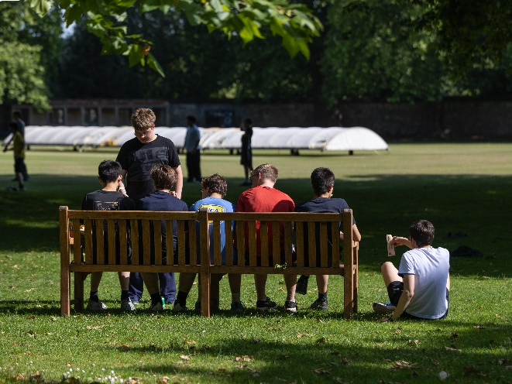

HOW TO APPLY

Only applications completed on the school website will be accepted. Please attach a full CV with your application.

Please note that applications will be dealt with as they arrive. Winchester College reserves the right to appoint before the deadline passes.

Closing date for applications: Midnight on Tuesday 4th August 2026

If you have any questions about this vacancy or the recruitment process, please email recruitment@wincoll.ac.uk.

APPLY HERE

Diversity and Inclusion
We embrace diversity and inclusion in the workplace and are committed to promoting a fair and supportive environment for all our employees. We are keen to welcome applications from all applicants that feel that they meet the requirements of the role, regardless of their background and culture.

Data Protection
Winchester College collects and processes relevant personal data as part of its everyday operations and is obliged to process it in accordance with the General Data Protection Regulation and Data Act 2018. The school is the Data Controller of this data under the Act and is registered with the Information Commissioner's Office. Its registration number is Z5751669.

If you have any queries or comments about this policy or how personal data is processed by the school, please contact the Bursar and his team by emailing: dataprotection@wincoll.ac.uk or by writing to: Data Protection, The Bursary, Winchester College, College Street, Winchester, SO23 9NA.


PART FIVE
10

ABOUT WINCHESTER COLLEGE

Winchester College was founded in 1382 by a radical educational reformer and has since been shaped by centuries of tradition.

Today, the School has 735 pupils. Over time, the School plans to admit up to 40 day pupils into the Sixth Form each year (around half of whom will be girls) and up to 60 girl boarders. This will bring the total School population to around 900 pupils, similar in size to Rugby and Harrow, but smaller than Sevenoaks, Oundle, Wellington and Eton. The number of boys boarding at 13+ will remain the same.

A recent milestone in Winchester’s history is the merger with The Pilgrims’ School, one of the leading academic prep schools for boys. The merger strengthens the historical ties between the two schools, ensuring that we both continue to provide an education of exceptional quality and breadth, while also creating new opportunities for increased collaboration and innovation.

The College has also recently completed a brand review and refresh, designed to provide prospective families with a clearer, more distinctive impression of what makes Winchester unique, and to sharpen the way we communicate our core values and messages.

Find out more

WHY WINCHESTER COLLEGE? 
EMPLOYMENT





Winchester College
College Street
Winchester, SO23 9NA
United Kingdom

www.winchestercollege.org

Twitter: @WinCol
Instagram: @winchestercollege

